NCIR HEDIS Extract Job Aid

- Enter your unique username and secure password on the North Carolina Immunization Registry Homepage: https://ncir.dhhs.state.nc.us/. Then click NCID Login.
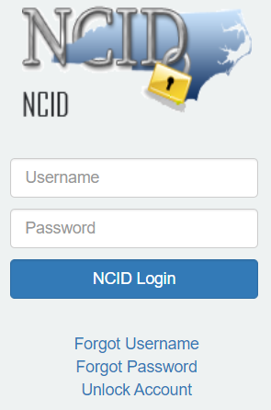
- Select the hedis query link from the left-hand menu bar.
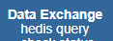

- You may enter a Job Name in the box (optional), then select the Choose File button to select the input file to upload. Click the Upload button. *See the file specs document for details on the import file.
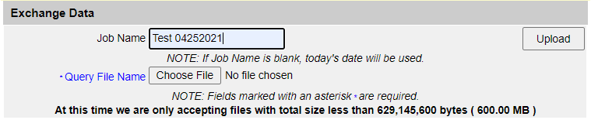

- Once the file has been uploaded, click the Check Status button to refresh the screen and check the status of the report.
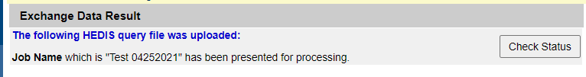

- Click the job name link once complete.
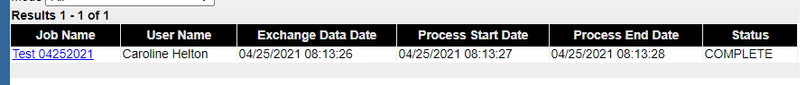

- Click the HEDIS Extract link for the results. Click the HEDIS Summary for a summary of the records.
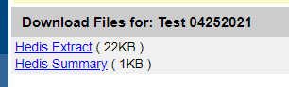

- The HEDIS Extract results contain the client-specific information. *See the file specs document for the details on output file format.

- The HEDIS Summary results contain a summary of the input and output records.
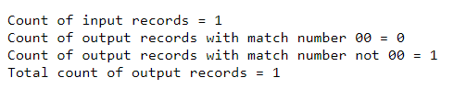

- When creating your .txt file, break your query into smaller files,
  - your query will complete in less time;
  - and generate your queries early in the morning. This will ensure your query is not stopped if it is still processing at midnight.

